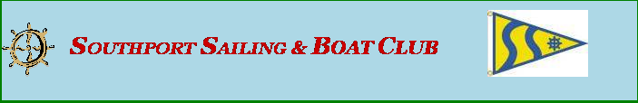

This table lists the Club’s events for year 2024 with the dates (where confirmed)
2024 Events
Month | Event | Coordinator | 2024 Dates
Jan | NONE
Feb | Event- Karaoke @ SJPCC | Walter | February 2
Mar | Event – Rock & Roll Party @ SJPCC  ****************  Crazy Cards @ SJPCC | Dan  Craig | March 8  March 28
April | Federal Point Cruise | Sid | April 19 - 21
May | Myrtle Beach Grande Dunes cruise  Around Dock Box | Kathy  Sid | May 17 - 19  Pop up event (TBD)
June | Georgetown /Charleston cruise  Avoid Charleston June 21-24 tournament  ----------------  Dock Party | Craig  Sid | June 14 - 18  TBD
July | July 4th Flotilla (date to be decided) in Southport  Jimmy Buffet Party  BOAT RAFT UP PARTY  (Bird Island) | Walt Faulconer  Susie  Tony | TBD  July 18  TBD
Aug | Beaufort / Oriental Cruise  --------------  Fish Fry (Woodlands) | Sid  Craig | August 9 & 10 Beaufort  August 11 - 13 Oriental  August 22
Sept | Cruise Location – Bald Head  Around Dock Box | Joe  Open | September 13 - 15  Pop Up event
Oct | Cruise – New Wilmington  -------------  Land Based event - TBD (Woodland) Pavilion  -------------  Ladies Bunco Night @ SJPCC | Open  Open  Deb Thompson | TBD  TBD  Oct 30
Nov | End of year party - Theme @ SJPCC  ---------------  Southport Wooden Boat Show | Open  George | November 15  November 4
Dec | Flotilla  Southport | Walt Faulconer | Dec 14

